***Solution*** ***Section* 2.4 – Integration of Rational Functions by Partial Fractions**

***Exercise***

Evaluate 

***Solution***











***Exercise***

Evaluate 

***Solution***







 







***Exercise***

Evaluate 

***Solution***

























***Exercise***

Evaluate 

***Solution***





















***Exercise***

Evaluate 

***Solution***









 

  



***Exercise***

Evaluate 

***Solution***

























 

 



***Exercise***

Evaluate 

***Solution***













 



***Exercise***

Evaluate 

***Solution***

|  |  |
| --- | --- |
|  |  |









***Exercise***

Evaluate 

***Solution***















***Exercise***

Evaluate 

***Solution***

 







 





***Exercise***

Evaluate 

***Solution***

Let 



















***Exercise***

Evaluate 

***Solution***



















***Exercise***

Evaluate 

***Solution***

Let 























***Exercise***

Evaluate 

***Solution***

|  |  |
| --- | --- |
|  |  |

***Exercise***

Evaluate 

***Solution***





 



***Exercise***

Evaluate 

***Solution***

















***Exercise***

Evaluate 

***Solution***







 

 







***Exercise***

Evaluate 

***Solution***











***Exercise***

Evaluate 

***Solution***







 

 











***Exercise***

Evaluate 

***Solution***

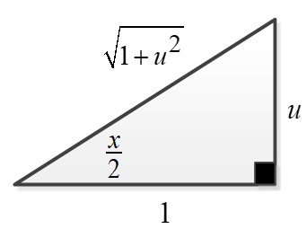



















***Exercise***

Evaluate 

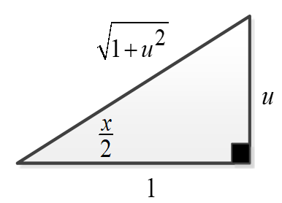***Solution***













 





***Exercise***

Evaluate 

***Solution***

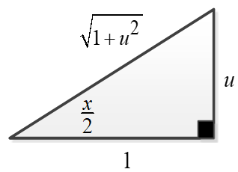



















***Exercise***

Evaluate 

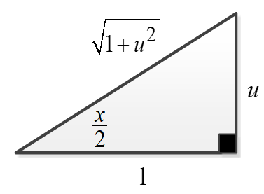***Solution***

Let 

























***Exercise***

Evaluate 

***Solution***













***Exercise***

Evaluate 

***Solution***













***Exercise***

Evaluate 

***Solution***















***Exercise***

Evaluate 

***Solution***





 





 



***Exercise***

Evaluate 

***Solution***













***Exercise***

Evaluate 

***Solution***

















***Exercise***

Evaluate 

***Solution***

















***Exercise***

Evaluate 

***Solution***

Let 

















***Exercise***

Evaluate 

***Solution***

Let 

















***Exercise***

Evaluate 

***Solution***

Let 



















***Exercise***

Evaluate 

***Solution***

Let 













***Exercise***

Evaluate 

***Solution***













***Exercise***

Evaluate 

***Solution***













***Exercise***

Evaluate 

***Solution***













***Exercise***

Evaluate 

***Solution***











***Exercise***

Evaluate 

***Solution***











***Exercise***

Evaluate 

***Solution***













***Exercise***

Evaluate 

***Solution***











***Exercise***

Evaluate 

***Solution***













***Exercise***

Evaluate 

***Solution***











***Exercise***

Evaluate 

***Solution***

Let 















***Exercise***

Evaluate 

***Solution***

Let 















***Exercise***

Evaluate 

***Solution***

















***Exercise***

Evaluate 

***Solution***











***Exercise***

Evaluate 

***Solution***















***Exercise***

Evaluate 

***Solution***













***Exercise***

Evaluate 

***Solution***











  

 









***Exercise***

Evaluate 

***Solution***







***Exercise***

Evaluate 

***Solution***















***Exercise***

Evaluate 

***Solution***









***Exercise***

Evaluate 

***Solution***











***Exercise***

Evaluate 

***Solution***















***Exercise***

Evaluate 

***Solution***















***Exercise***

Evaluate 

***Solution***









 





***Exercise***

Evaluate 

***Solution***













 















***Exercise***

Evaluate 

***Solution***



























***Exercise***

Evaluate 

***Solution***













***Exercise***

Evaluate 

***Solution***



























***Exercise***

Evaluate 

***Solution***















***Exercise***

Evaluate 

***Solution***







 







***Exercise***

Evaluate 

***Solution***













***Exercise***

Evaluate 

***Solution***













***Exercise***

Evaluate 

***Solution***















***Exercise***

Evaluate 

***Solution***













 







***Exercise***

Evaluate 

***Solution***









 









***Exercise***

Evaluate 

***Solution***

















***Exercise***

Evaluate 

***Solution***









 

 







***Exercise***

Evaluate 

***Solution***









 





***Exercise***

Evaluate 

***Solution***







 













***Exercise***

Evaluate 

***Solution***















***Exercise***

Evaluate 

***Solution***













***Exercise***

Evaluate 

***Solution***













***Exercise***

Evaluate 

***Solution***

















***Exercise***

Evaluate 

***Solution***











***Exercise***

Evaluate 

***Solution***







  







***Exercise***

Evaluate 

***Solution***







  







***Exercise***

Evaluate 

***Solution***







  









***Exercise***

Evaluate 

***Solution***

















***Exercise***

Evaluate 

***Solution***

















***Exercise***

Evaluate 

***Solution***

















***Exercise***

Evaluate 

***Solution***































***Exercise***

Evaluate 

***Solution***











  













***Exercise***

Evaluate 

***Solution***























***Exercise***

Evaluate 

***Solution***

















***Exercise***

Evaluate 

***Solution***





















































***Exercise***

Evaluate 

***Solution***































***Exercise***

Evaluate 

***Solution***







































***Exercise***

Evaluate 

***Solution***







  













***Exercise***

Evaluate 

***Solution***







  



















***Exercise***

Evaluate 

***Solution***





















***Exercise***

Evaluate 

***Solution***







 















***Exercise***

Evaluate 

***Solution***















***Exercise***

Evaluate 

***Solution***















***Exercise***

Evaluate 

***Solution***



















***Exercise***

Evaluate 

***Solution***









***Exercise***

Evaluate 

***Solution***







  











 ***Power Rule***



 ***Product Rule***



***Exercise***

Evaluate 

***Solution***









 

 













***Exercise***

Evaluate 

***Solution***













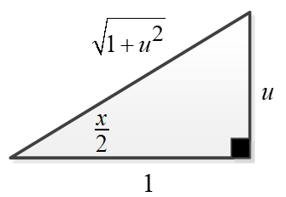 



























***Exercise***

Evaluate 

***Solution***



























 















 



***Exercise***

Find the volume of the solid generated by the revolving the shaded region about *x*-axis

***Solution***



































***Exercise***

Find the area of the region bounded by the graphs of 

***Solution***

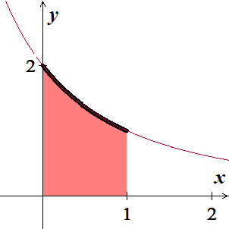



















***Exercise***

Find the area of the region bounded by the graphs of 

***Solution***



 

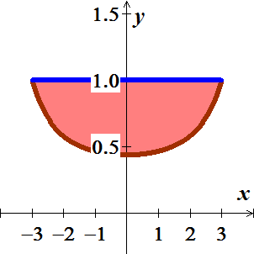 













***Exercise***

The region in the first quadrant that is enclosed by the *x*-axis, the curve  , and the lines  and  is revolved about the *x*-axis to generate a solid. Find the volume of the solid.

***Solution***

























***Exercise***

Find the length of the graph of the function 

***Solution***





































***Exercise***

Consider the region bounded by the graphs .

1. Find the volume of the solid generated by revolving the region about the 
2. Find the centroid of the region.

***Solution***

1. 









 

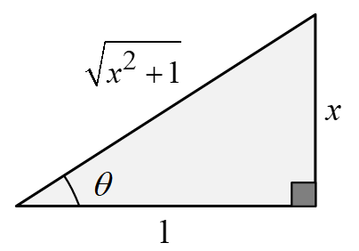 











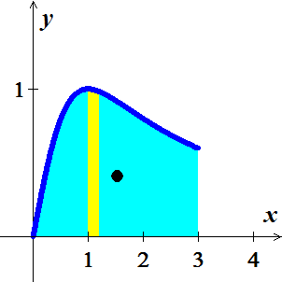 

1. 







 

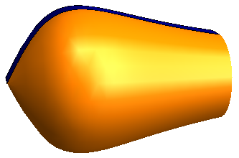 





 













***Exercise***

Consider the region bounded by the graph .

Find the volume of the solid generated by revolving this region about the .

***Solution***





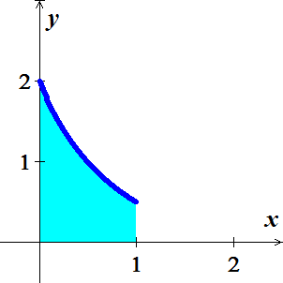















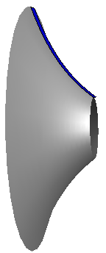 









***Exercise***

A single infected individual enters a community of *n* susceptible individuals. Let *x* be the number of newly infected individuals at time *t*. The common epidemic model assumes that the disease spreads at a rate proportional to the product of the total number infected and the number not yet infected. So,

 and you obtain

 Solve for *x* as a function of *t*.

***Solution***



















 













 

***Exercise***

Evaluate  in ***two*** different ways.

***Solution***

1. Partial method























1. Let 













